**MongoDB Atlas Setup: Server and database are live**

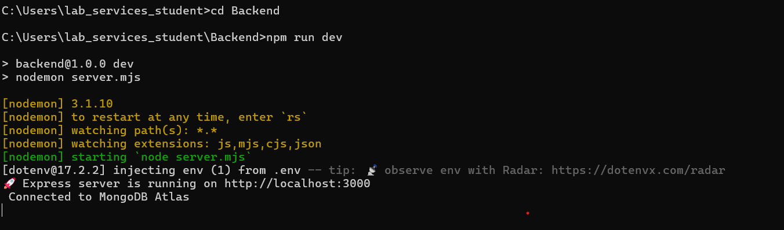

**Test Basic Routes**

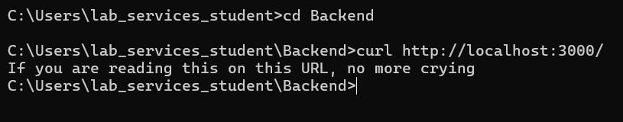

**Test /test Route**

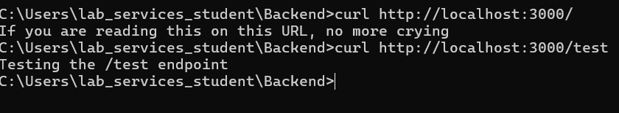

**Test /add-note POST Route**



**View in MongoDB Atlas**

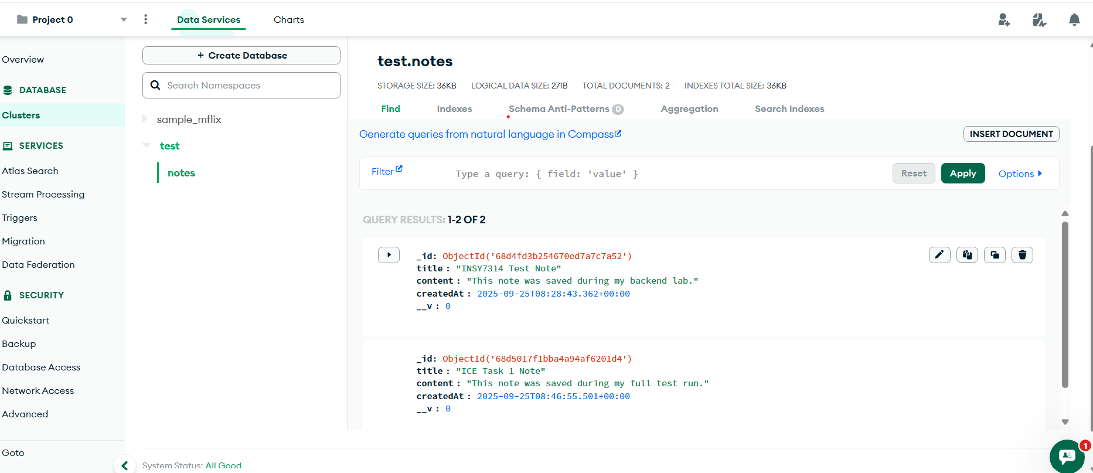

**Folder Structure**

